1 INTRODUCTION

AN INDEX OF ECONOMIC FREEDOM

An index of economic freedom measures jurisdictions against each other in terms of parameters such as trade freedom, tax burden, judicial effectiveness, and more. These factors may be weighted according to their influence on economic freedom and compiled into a single score that allows for a ranking.

An index of economic freedom measures and ranks countries according to relevant standards judged by the creators of the index. Not all economists will agree on the relevant criteria, of course.

Indices of economic freedom consider free-market economies at the high-end of the spectrum for analysis. There is a firm correlation between both the earnings a country's citizens enjoy and the index of economic freedom ranking of such country. Investors can use the index of economic freedom as a faster way to observe the changes in economies.

Using the Economic Freedom Index, users can discover innovative ways to use the index in science, public policy, enterprise, and advocacy. The index is an excellent analytical tool for evaluating 186 economies worldwide, and each country page is a platform for examining the political and economic trends of a nation in depth.

PURPOSE

The Heritage Foundation website states that "Economic freedom is the fundamental right of every human to control his or her own labor and property. In an economically free society, individuals are free to work, produce, consume, and invest in any way they please. In economically free societies, governments allow labor, capital, and goods to move freely, and refrain from coercion or constraint of liberty beyond the extent necessary to protect and maintain liberty itself." By publishing yearly reports the foundation attempts to highlight where such freedoms do and don't exist.

The Heritage Foundation reports that the top 20% on the index have twice the per capita income of those in the second quintile, and five times that of the bottom 20%.[Carl Schramm](https://en.wikipedia.org/wiki/Carl_Schramm), who wrote the first chapter of the 2008 Index, states that cities of Medieval Italy and mid-19th century Midwestern American cities all flourished to the degree they possessed economic fluidity and institutional adaptiveness created by economic freedom.

According to [Will Wilkinson](https://en.wikipedia.org/wiki/Will_Wilkinson) of the [libertarian](https://en.wikipedia.org/wiki/Libertarianism) [think tank](https://en.wikipedia.org/wiki/Think_tank) [Cato Institute](https://en.wikipedia.org/wiki/Cato_Institute), studies show that higher economic freedom correlates strongly with higher self-reported happiness.

According to the Cato Institute, higher economic freedom promotes participation and collaboration. Also claimed is that higher economic freedom is extremely significant in preventing wars; according to their calculations, freedom is around 54 times more effective than democracy (as measured by *Democracy Score*) in diminishing violent conflict.

2.Problem Definition & Design Thinking

EMPATHY MAP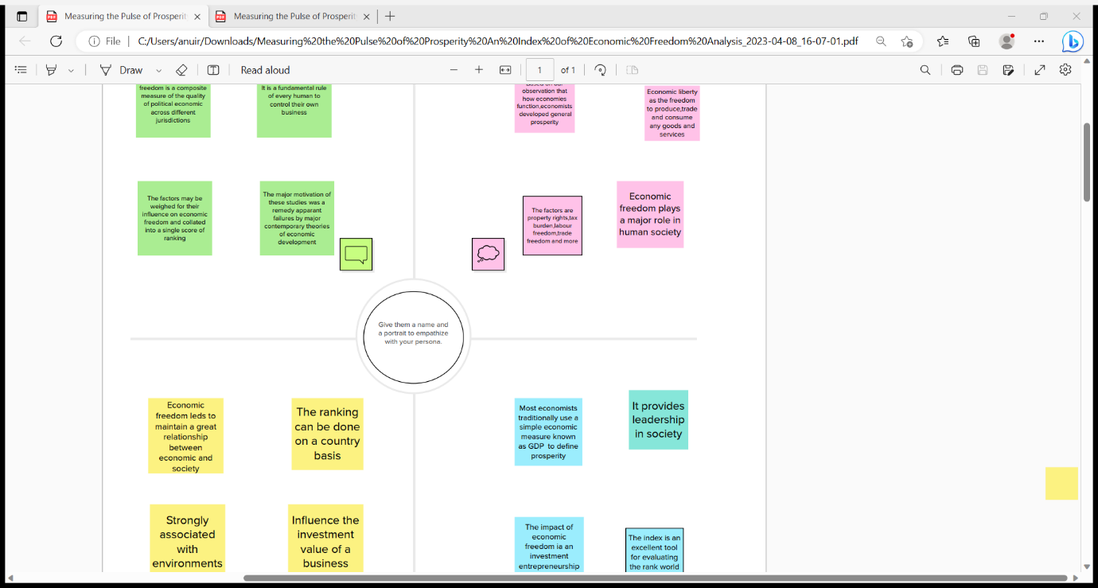

BRAINSTROM AND IDEA PRIORITIZATION

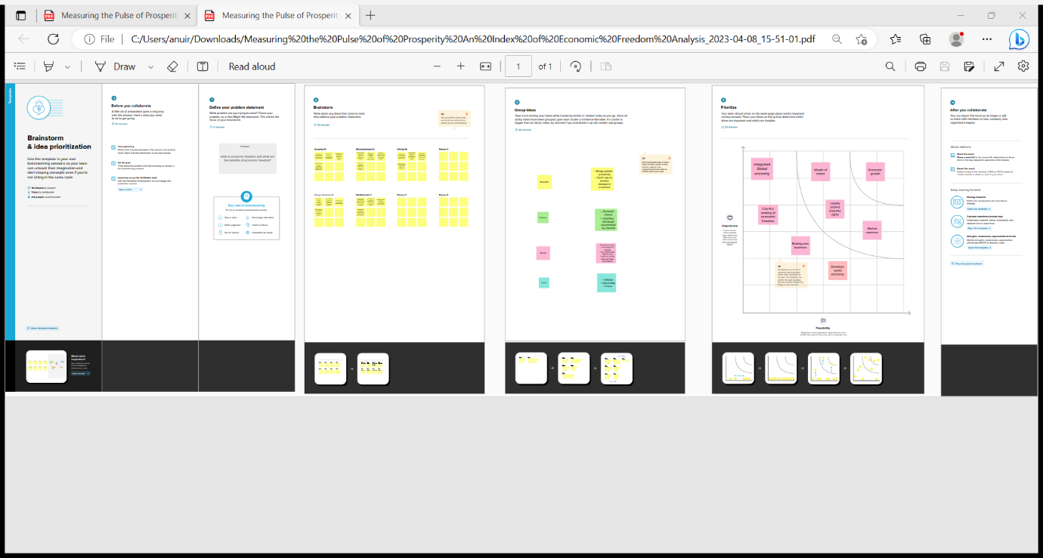

3 RESULTS

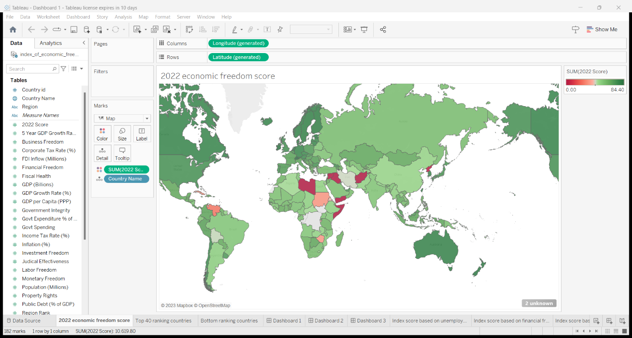

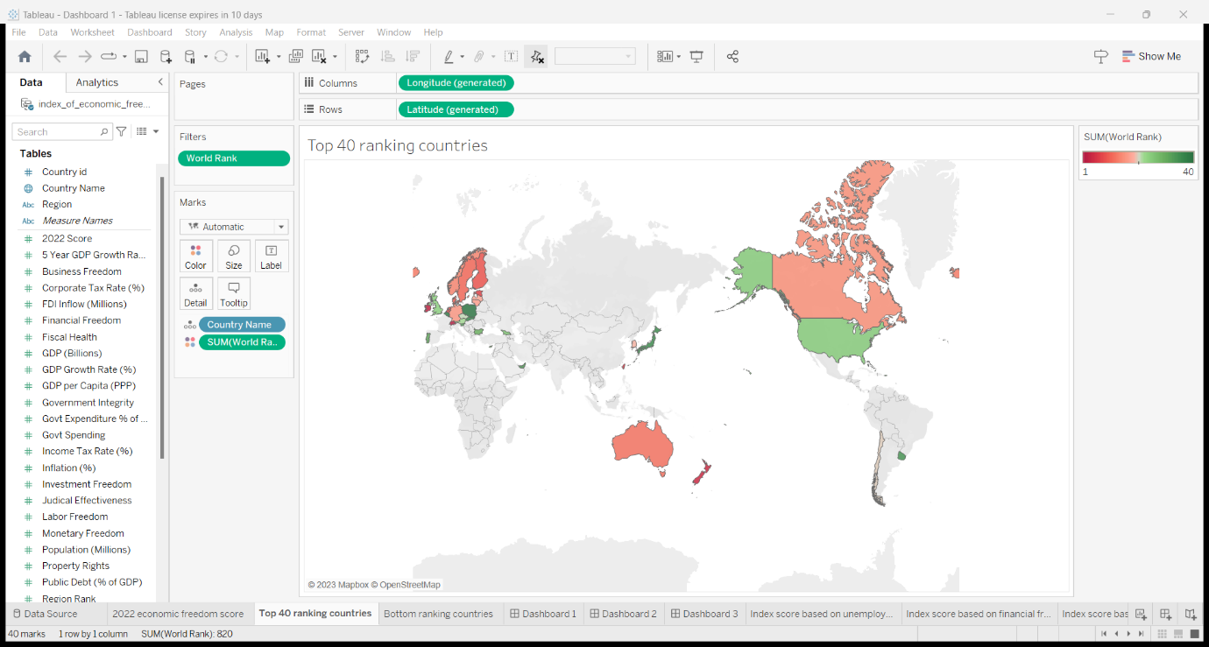

L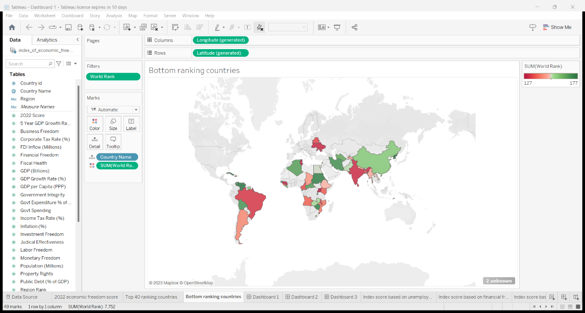

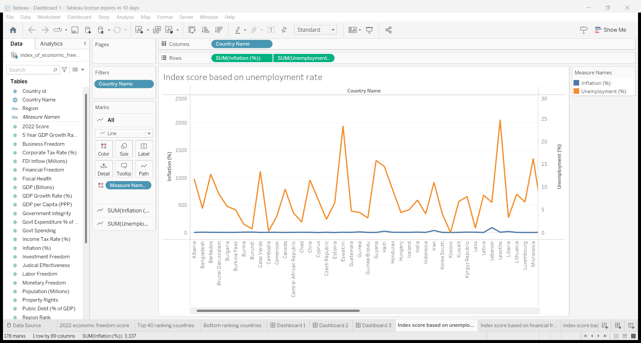

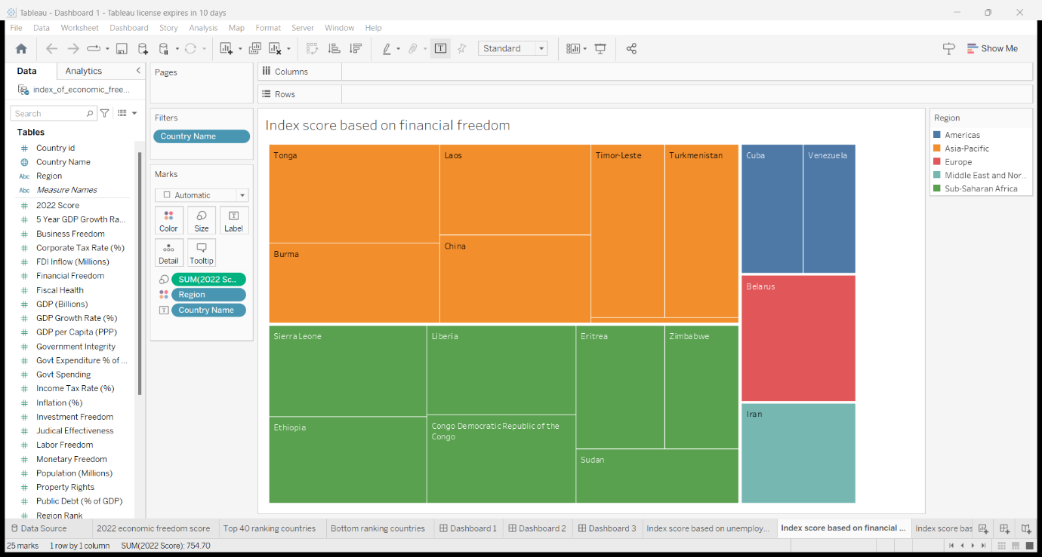

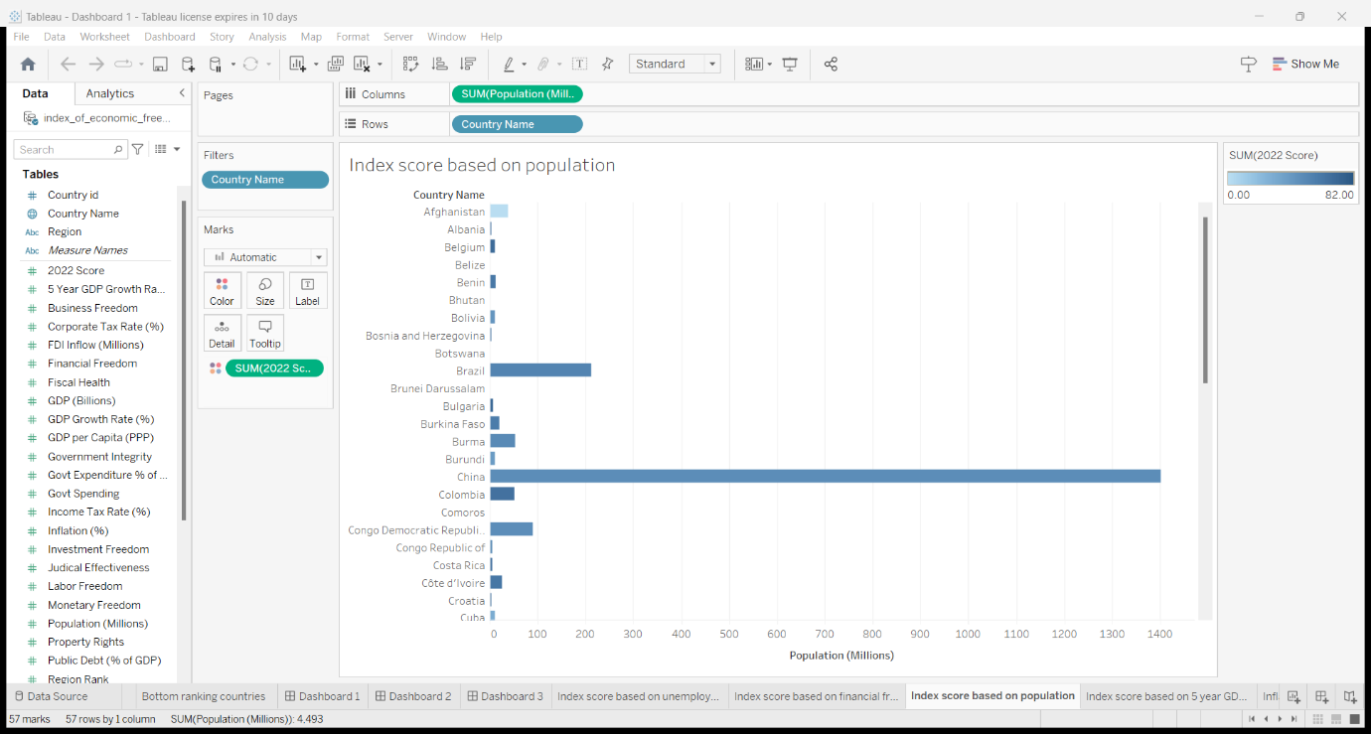

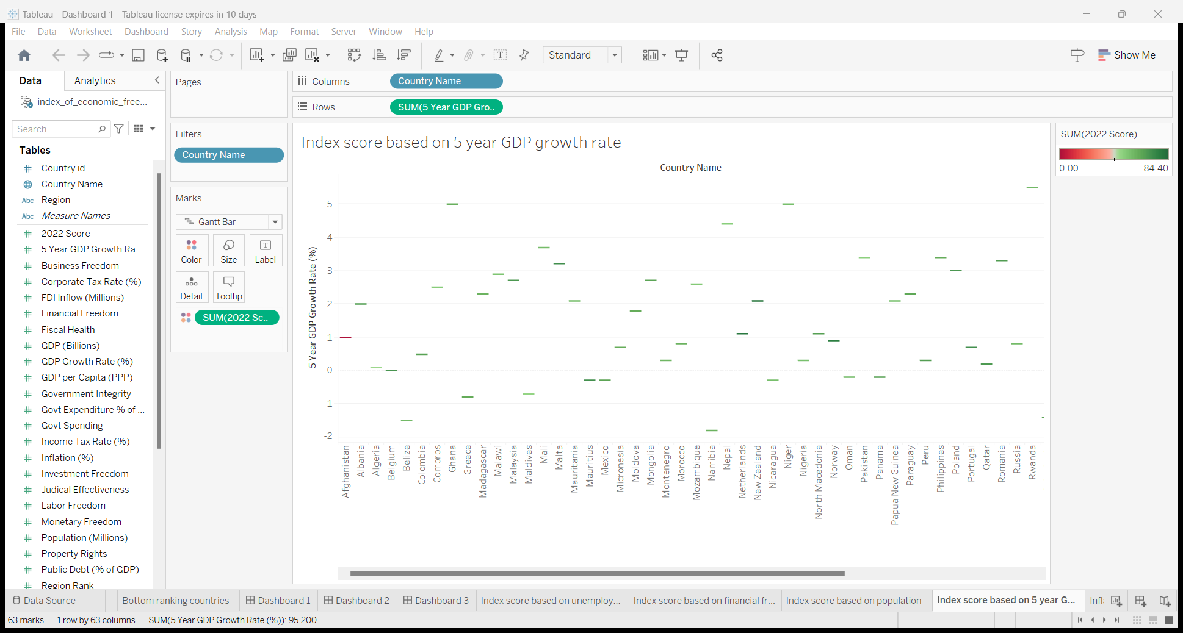

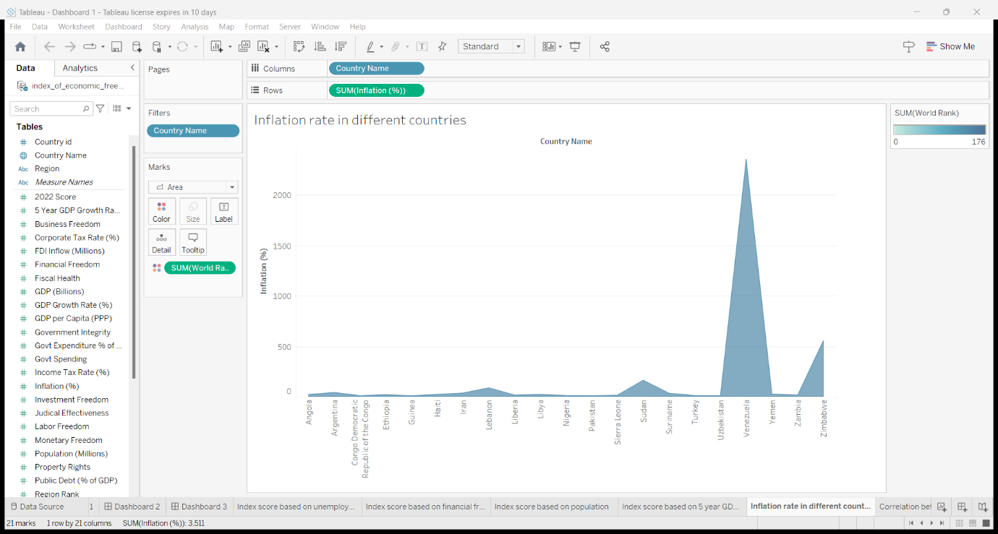

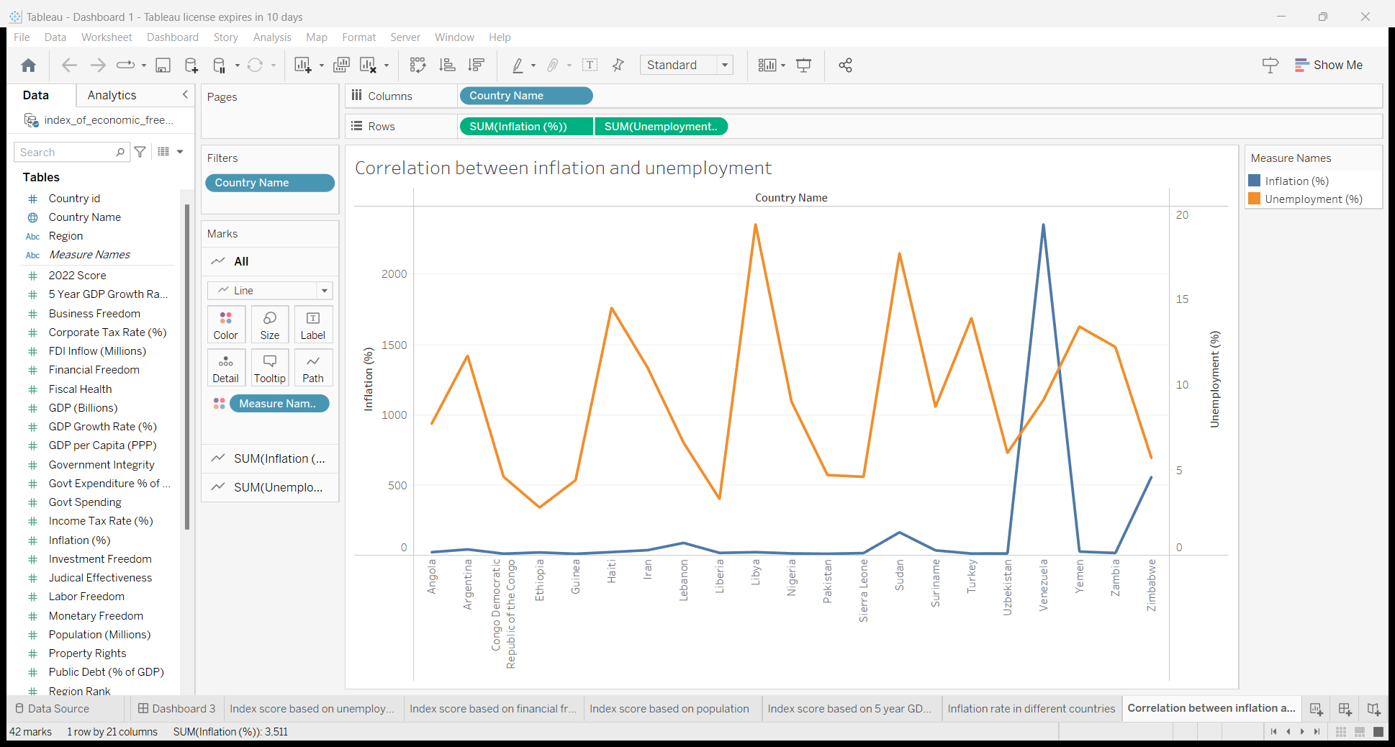

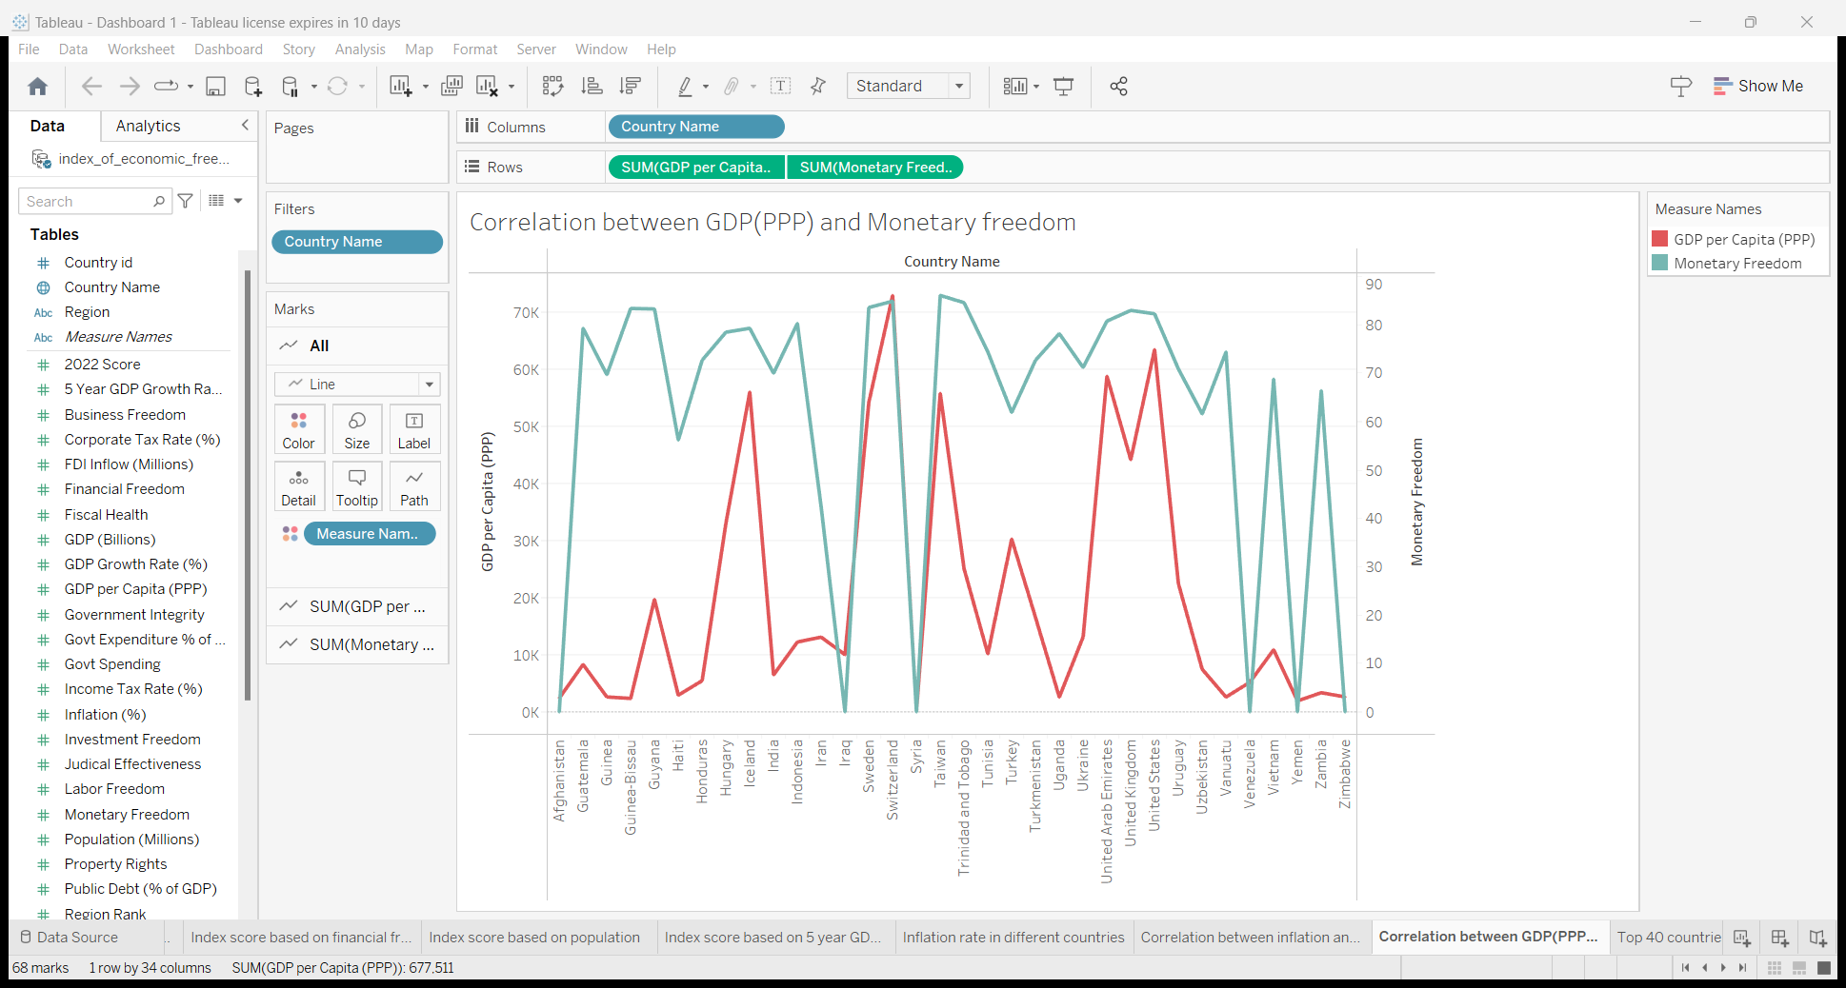

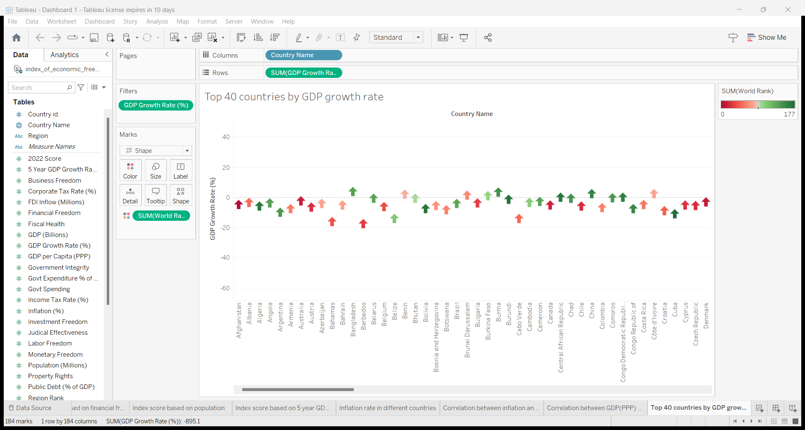

DASHBOARD 1

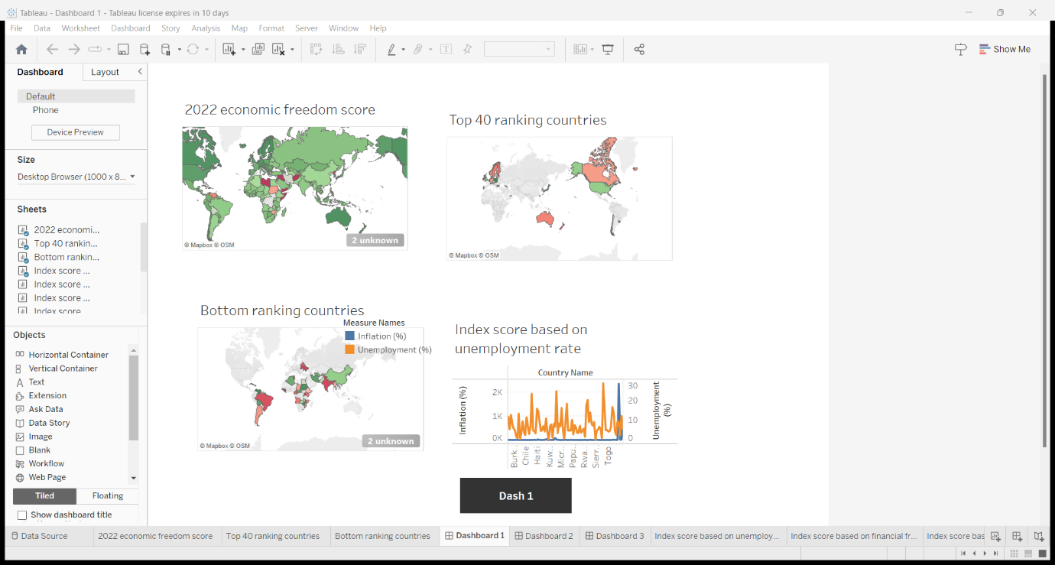

DASHBOARD 2

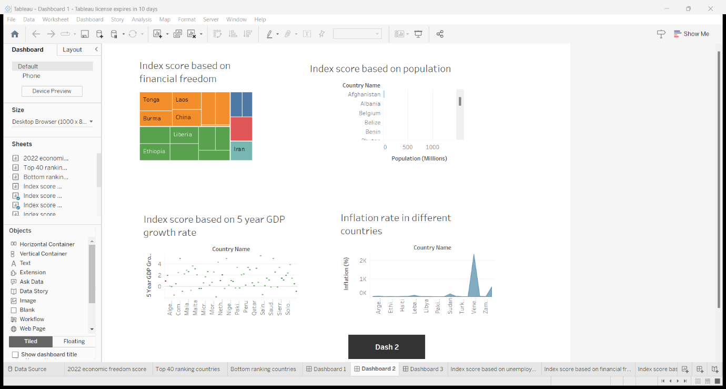

DASHBOARD 3

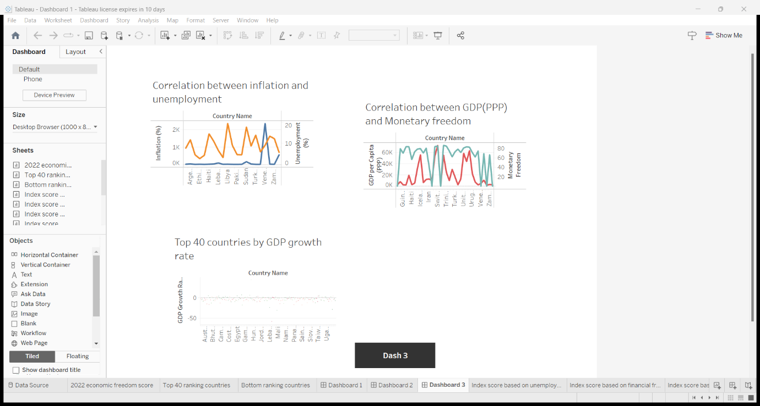

STORY

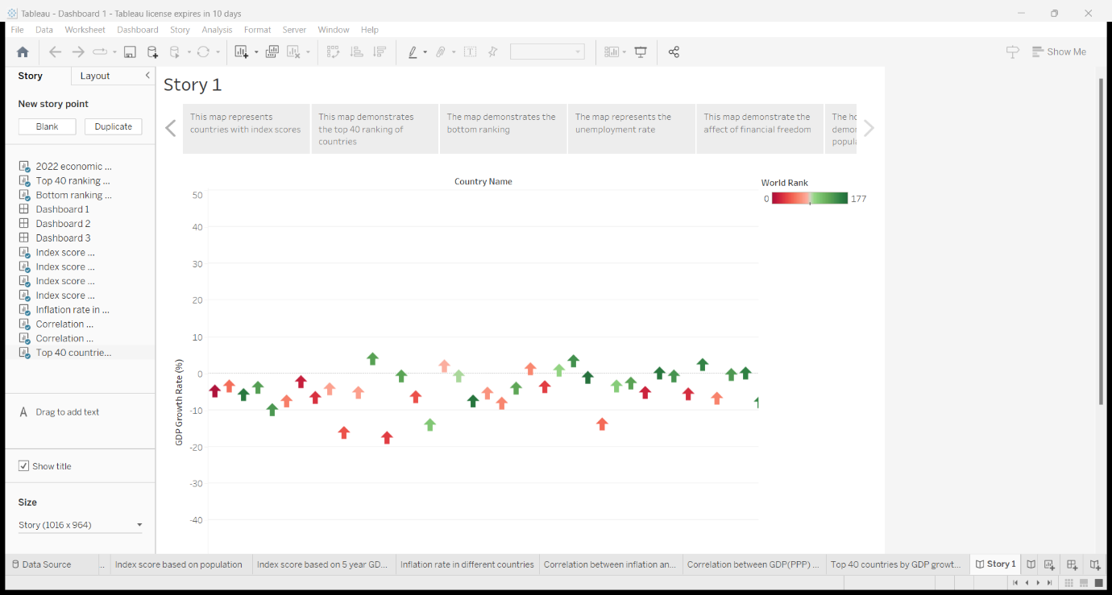

VISUAL CODING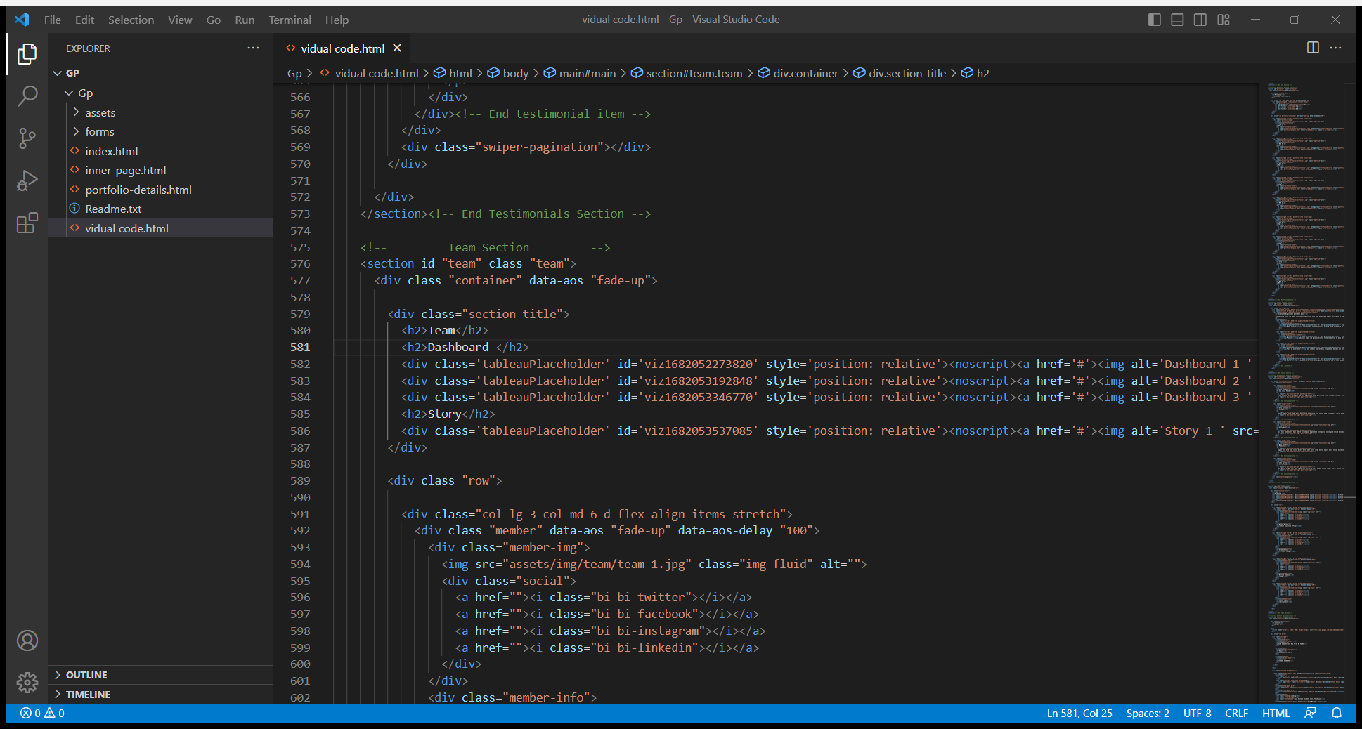

OUTPUT

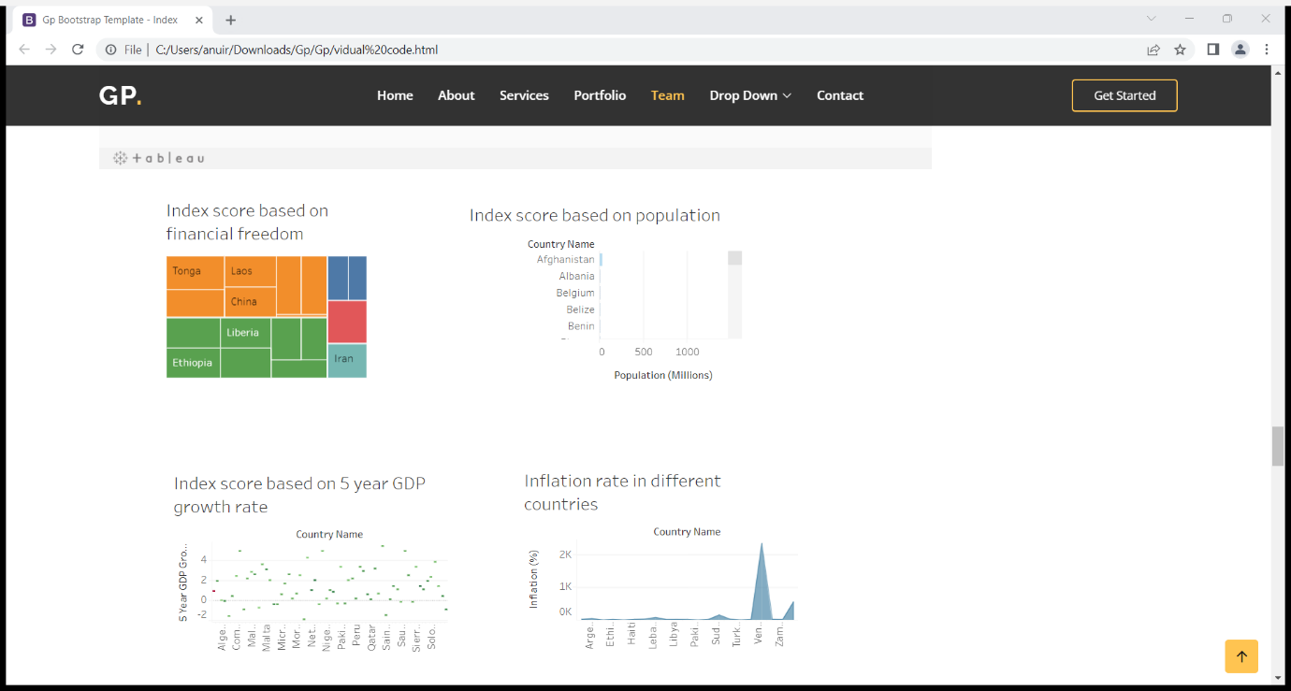

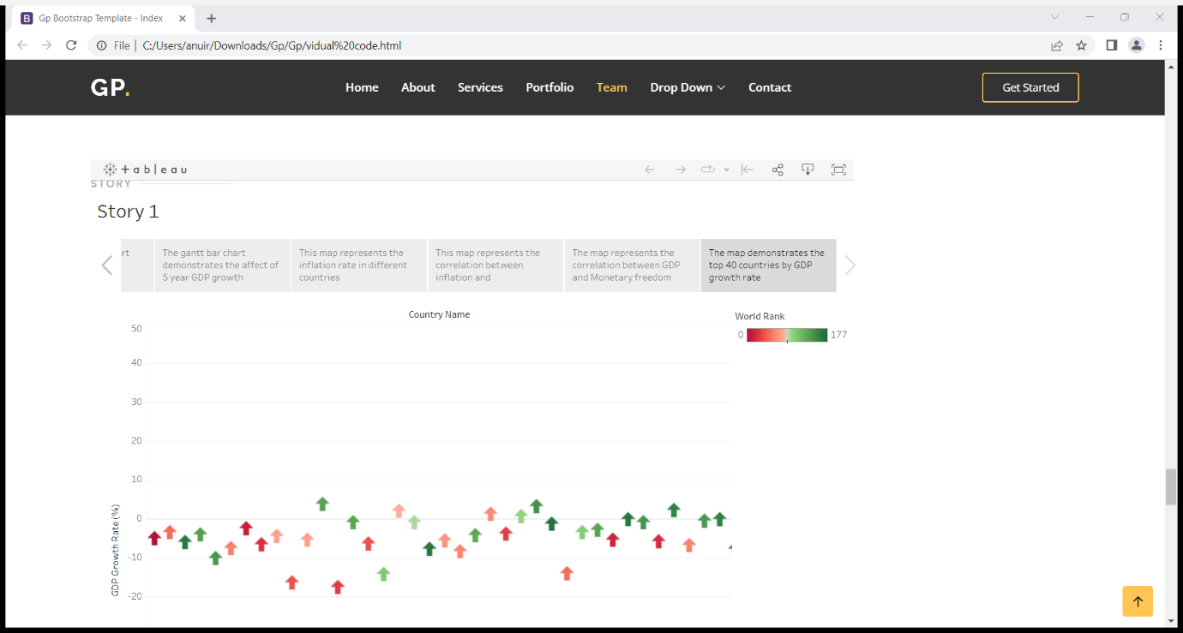

4 ADVANTAGES

**Economic freedom is good for economic growth**

Even a tiny level of growth compounds heavily over time. An economy that grows half a percent faster than it would have otherwise grown over a 100-year period will experience [400 percent more growth](https://www.youtube.com/watch?v=w7o0UQbDr4g) overall than without that extra half a percentage point. The difference between 4 percent and 3 percent annual growth determines whether it will take an economy 18 years to double in size or 24 years (simply [divide 72](https://en.wikipedia.org/wiki/Rule_of_72) by average annual growth to determine how long it will take for an economy to double in size).

**Economic freedom makes everyone richer**

Economic growth translates to higher incomes not for just the wealthy, but for everyone. To quote from Fraser’s findings, in purchasing power parity adjusted 2011 dollars, per capita income in the freest nations was $39,899, compared to $6,253 in the least free nations. These numbers are just averages, so technically they may be overstated if an income distribution is right-skewed.

**Economic freedom smooths the business cycle**

Economic freedom not only helps the economy grow faster overall, but it also makes growth less volatile. There are only three studies on the subject that I am aware of (published by [Noel Campbell and Thomas Snyder](http://www2.southeastern.edu/orgs/econjournal/index_files/JIGES%20DEC%202012%203-30-2013%20V6%20CAMPBELL%20SNYDER.pdf) in 2012, [Jody W. Lipford](http://econpapers.repec.org/article/jpejournl/710.htm) in 2007, and [John W. Dawson](https://www.fraserinstitute.org/uploadedFiles/fraser-ca/Content/research-news/research/publications/economic-freedom-of-the-world-2010-ch4.pdf) in 2010), but all yield the same results: a negative correlation between economic freedom and volatility in the business cycle. Campbell and Snyder do find that there are diminishing returns to the positive effects economic freedom yields for the business cycle, but there is no doubt that the effects are positive.

**Economic Freedom Helps the Environment**

. The most basic explanation is that private ownership incentivizes the conservation of resources. When everyone owns a resource in common, the incentive to conserve is removed. Before we dive into the evidence, it’s worth exploring why we should expect economic freedom to help the environment This is called the [tragedy of the commons](http://www.econlib.org/library/Enc/TragedyoftheCommons.html). While someone may conserve a resource on their own private property because they know it will be worth more in the future, the incentive to conserve disappears when the possibility that someone else can take the resource becomes part of the equation.

DISADVANTAGES

### **Monopolies**

There are natural monopolies such as utilities, sewer services, and train lines that present a big issue to free markets. In such markets, the cost to enter is huge. For example, a utility company may need to create a whole new supply network to customer’s houses – something that is economically inefficient. As a result, one company may be able to dominate the market and charge prices over and above the market rate.

### **Absence of Public Goods**

In a free market, public goods such as free healthcare and education don’t exist – they are run by private enterprises. Ultimately, this may mean that many are unable to access such services as they are unable to afford them.

### **Negative Externalities**

When there are no regulations or restrictions, it is said that businesses will be free to produce negative [externalities](https://boycewire.com/externalities-definition/) such as pollution. If there are no set laws to limit or restrict a firm’s air, water, or waste pollution, then society as a whole pays the consequence

### **Race to the bottom**

One of the commonly stated disadvantages of the free markets is the said ‘race to the bottom’. In other words, in a bid to become as profitable as possible, businesses reduce quality and cut corners, such as safety, in order to maximise profits. Ultimately, the consumer ends up worse off due to poor quality goods and services.

### **Income Inequality**

One significant drawback of the free market system is the potential for income inequality. Since rewards are based on individual productivity and success, those with higher skills, resources, or opportunities tend to accumulate more wealth, leading to a widening gap between the rich and the poor.

### **Exploitation of Workers**

In the pursuit of profits, some businesses in a free market system may engage in exploitative practices, such as paying low wages or neglecting worker safety. Without regulations to protect workers, these practices can lead to a deterioration of working conditions and a lower overall quality of life for some segments of the population.

6 APLLICATIONS

Generally, countries with higher economic freedom have higher gross domestic product per capita and its growth rates, as well as better health care, education quality, environment protection, income equality, and happiness results.

There is a positive correlation between economic freedom and a country's overall prosperity and growth rate due to economic development.

6 CONCLUSION

significant boosts to long-term economic growth (GDP) a better skilled and more productive National economic goals include: efficiency, equity, economic freedom, full employment, economic growth, security, and stability.

7 FUTURE SCOPE

National economic goals include: efficiency, equity, economic freedom, full employment, economic growth, security, and stability.

8 APPENDIX

<https://drive.google.com/file/d/1ccH9-8HrjnkNSLISfgMfq7AinQJB0I_S/view?usp=drivesdk>

<https://github.com/Anupriya148/Measuring-the-pulse-of-prosperity-An-index-of-economic-freedom.git>